ML sessional 01 Fa20 (Copy) (Machine Learning - FA20)

Hi SP18-BCS-170@isbstudent.comsats.edu.pk, when you submit this form, the owner will be able to see your name and email address.

11,

Using the "Average Disorder formula" OR "Entropy and Information Gain formulae" for ID3 algorithm, what will be the average disorder of "Restaurant" in the following data set (at root level)?. Single choice.

(1 Point)

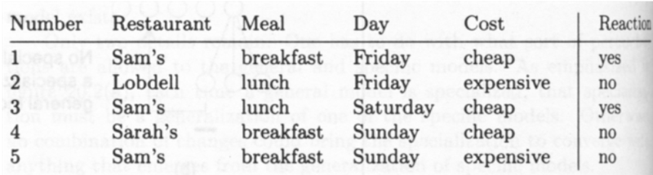

0.23

0.43

0.33

0.53

0.63

22,

Using the "Average Disorder formula" OR "Entropy and Information Gain formulae" for ID3 algorithm, what will be the average disorder of "Meal = Lunch" in the following data set (at root level)?. Single choice.

(1 Point)

0.43

0.60

0.40

0.20

33,

Using the "Average Disorder formula" OR "Entropy and Information Gain formulae" for ID3 algorithm, what will be the average disorder of "Day = Friday" in the following data set (at root level)?. Single choice.

(1 Point)



0.60

0.23

0.20

0.40

44,

Total Number of attributes in the given data set are?. Single choice.

(1 Point)



4

6

7

5

3

55,

Data in the following data set belongs to the unsupervised class of machine learning algorithms?. Single choice.

(1 Point)



False

True

66,

ID3 algorithm updates the model in batch mode?. Single choice.

(1 Point)

True

False

77,

Missing data does not impact the accuracy of the predicting model?. Single choice.

(1 Point)

Maybe

True

False

88,

Linear Regression is used to create clusters?. Single choice.

(1 Point)

True

False

99,

Logistic Regression is just another name for Supervised Machine Learning?. Single choice.

(1 Point)

True

False

1010,

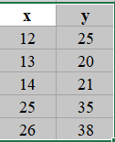

Consider the following data set for Linear Regression. what will the value of y-intercept (truncated to first decimal point)?. Single choice.

(1 Point)

7.47

1.1

6.27

7.4

3.4

5.4

1111,



Consider the following data set for Linear Regression. what will the value of slope (m) (truncated to first decimal point)?. Single choice.

(1 Point)

4.1

1.1

2.1

3.1

5.1

0.1

1212,



Consider the following data set for Linear Regression. what will the value of n?. Single choice.

(1 Point)

1

5

3

7

9

1313,

Error in Linear Regression between the actual and the predicted values is calculated by _________. Single choice.

(1 Point)

SSE

None of the above

All of the above

MSSE

RMSE

1414,

Basic assumption in Naieve Bayes classification is that the classes are dependent. Single choice.

(1 Point)

True

False

1515,

The formula for Bayes theorem is: P(H|X) = P(X|H) P(H) / P(X) the posterior probability in the formula is __________. Single choice.

(1 Point)

P(X)

P(H|X)

P(X|H)

P(H)

1616,

The formula for Bayes theorem is: P(H|X) = P(X|H) P(H) / P(X) the prior probability in the formula is __________. Single choice.

(1 Point)

P(X)

P(H)

P(H|X)

P(X|H)

1717,

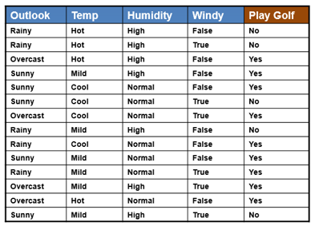

Consider the following data set for Naieve Bayes Classification. What is the probability of outlook=Overcast and PlayGolf=yes.. Single choice.

(1 Point)

0/5

1/5

4/5

2/9

3/9

4/9

1818,

Consider the following data set for Naieve Bayes Classification. What is the probability of Temp=Mild and PlayGolf=no.. Single choice.

(1 Point)

1/5

6/14

3/5

2/9

6/9

2/5

1919,



Consider the given data set. What will be the answer to the question whether the Golf will be played on a windy day with high humidity and cool temperature while the outlook remains sunny?. Single choice.

(1 Point)

yes

No

Maybe

2020,

Bayesian Classification belongs to the Reinforcement class of Machine Learning?. Single choice.

(1 Point)

False

True